Module 4
CS-360
Kaitlyn OConnell
2026-10-04
UI Design
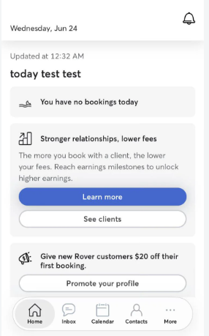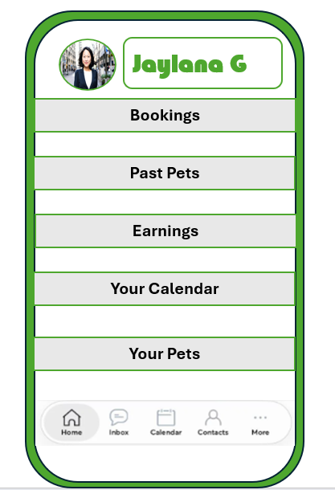

I decided to update the Rover home screen to make it more user-friendly and useful without changing the main purpose of the app. I wanted the home screen to give users quick access to the information they are most likely to need instead of making them search through different sections of the app.
At the top of the screen, I kept the user's profile, which is interactive and allows them to access their account and profile information. Underneath, I added sections for Bookings, Past Pets, Earnings, Calendar, and My Pets. Each section is interactive and takes the user to more detailed information. Bookings would show upcoming, past, and pending bookings, including information about the pet, owner, sitter, dates, and booking status. This would work for both users who are booking a sitter and users who are providing pet-sitting services.
The Past Pets section gives sitters a quick way to see pets they have cared for before, along with their booking history, notes, and reviews. Earnings provides sitters with a view of their monthly and yearly earnings. I also wanted this section to include helpful tools, such as saving money for taxes and quick information about potential tax benefits of using pet sitting as a business. The Calendar gives users a simple week or month view where they can see upcoming pet visits, bookings, and vacations. My Pets gives pet owners quick access to their pets' profiles, including information they may need when booking services or rebooking with a sitter.
For the visual design, I used Rover's green color to keep the screen connected to the app's branding, but I made the interface more bubbly by using rounded cards, buttons, and softer shapes. I also used icons and spacing to separate each section so the screen is easy to scan. The most important information is placed where users can find it quickly, while additional details are available by tapping into each section. Interactive areas are shown through buttons, cards, icons, and other visual cues.
I wanted to add more useful information without making the home screen feel overwhelming. The biggest challenge was fitting several new features onto one screen while keeping it simple. Using separate cards helped solve this because users can see a quick summary without being given too much information at once. The redesign makes the home screen feel more like a personal dashboard while still keeping the familiar Rover experience.

